LIVERPOOL ASSOCIATION OF MATCH OFFICIALS
(Formerly the LIVERPOOL SUNDAY FOOTBALL REFEREES SOCIETY)
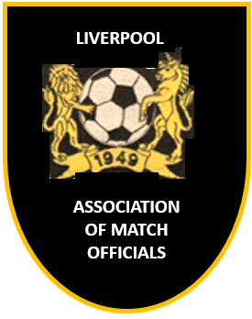
APPLICATION FOR MEMBERSHIP
Season 1st September 2020 to 31st August 2021

Date of Application:
First Name:
Surname:

 | Address:
 | Town |  |  |  | Postcode:
 | Telephone No: |  |  |  | Mobile:
 | Referee Level |  |  |  | Date of Birth |  | / /
 | Email address:
 | League(s) Registered with
Membership fee payable from 1st September 2020: |  |  |  | Full Member £20.00 |  | {includes £4.00 RA insurance premium }
 |  |  |  | Junior Member (under 18 ) £10.00 (*under 18’s – first season FREE)
Please Note: Insurance cover runs from the date of renewal of your membership – there is no overlap

Society meetings are held on the last Thursday of each month (except June and July) at
Christ the King Parish Club, Score Lane / Queens Drive, Liverpool L16 6AW

Payment | Full £20.00 |  |  | Junior £10.00

Please send to: Peter Morton, 40 Sunnybank Road, Childwall, Liverpool L16 7PW.

CHEQUES SHOULD BE MADE PAYABLE TO “LIVERPOOL SUNDAY FOOTBALL REFEREES SOCIETY”

Pay Direct – Electronic or Bank Deposit: LIVERPOOL SUNDAY FOOTBALL REFEREES SOCIETY
HSBC Sort Code: 40 29 08 Account No: 82839482

